ChassisSim FSAE tips and tricks

The purpose of this document is to outline some tips and tricks that are specific to interfacing ChassisSim with a Formula SAE car. Even though ChassisSim has been designed for use for professional motorsports, we’ll cover some setup tricks on how ChassisSim can be adapted for FSAE use.

Setting up the ChassisSim environment

The template you need to start on is the FSAE template. Please note it is strongly suggested to open the template and then save the car file using File-> Save As in a different directory. A suggested Directory structure is C:\ChassisSim Technologies\Models\FSAE. Then use File->Open to access the car file.

In terms of setting up the units to be entered this can be accessed in View->Select Units to use. This will display the following dialog,

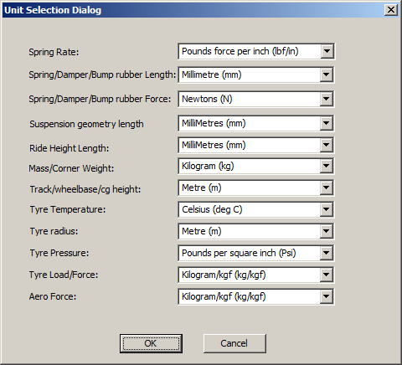

This can be configured to the units the user desires.

Also please note when setting up the suspension the datum is setup on the front axle on the car centreline on the ground. Also when entering asymmetric suspension all y locations (lateral locations) are assumed positive.

The other modification that needs to be done is setting up the default circuit settings. These settings are accessed in Circuit->Modelling options. When ChassisSim is shipped default with circuit racing settings for race car. However this is easily adjusted. Select Circuit->Modelling options and apply the following settings illustrated below,

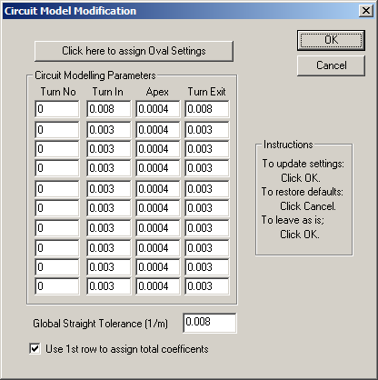

Press OK to commit these changes.

Creating curvature files.

The curvature file tells ChassisSim the path to follow. Given the prevelance of budget data systems in FSAE it is strongly recommended to use the moving average filter set to 0.8s. This is accessed using Circuit -> Create/Filter Curvature file. The appropriate setting for this is shown below,

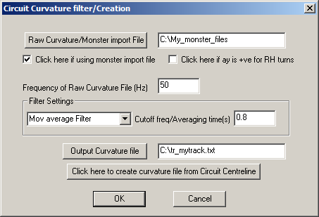

It is also recommended to put a cap of 0.25/m on the value of the curvature file.

Creating monster files with limited data

The monster file import system is one of the key features ChassisSim uses. If you are missing data for the monster file if in doubt set the relevant column to 0’s. For example if the damper data is missing is the monster file would look like this,

0 7392.94 -0.03 0.1 0 0 0 0 0 100 207.92
1.174 7395.56 -0.03 0.11 0 0 0 0 0.03 100 207.99
2.346 7398.33 -0.02 0.11 0 0 0 0 0.06 100 208.07
3.52 7401.26 -0.02 0.12 0 0 0 0 0.08 100 208.15
4.693 7404.28 -0.02 0.12 0 0 0 0 0.09 100 208.24

However please bear in mind that with limited comes a compromise in model accuracy.

Tyre modelling.

Given the wide variety of tyres available for FSAE there are a number of steps that can be taken to quickly dial a tyre model in. The first step is to compare actual steer vs simulated steer. If the slip angles in the tyre are too great you will be faced with the following overlay,

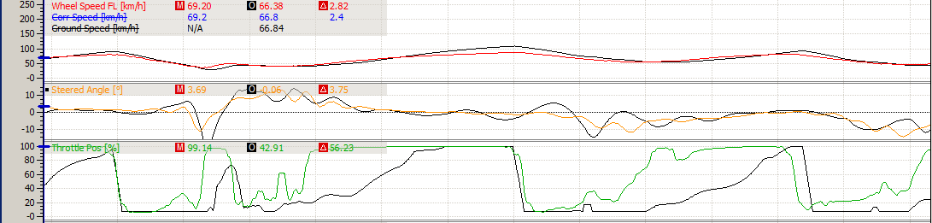

The middle trace is the steering, the coloured is actual and the simulated data. As we can see far too much steering lock is being applied by the simulator. If this situation is encountered reduce the tyre peak slip angles all around. This can be easily achieved by clicking on the tyres and click on the tyre quick start tab. This displays the following dialog,

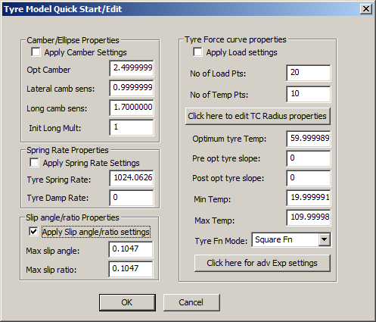

Enter in the desired slip angle (in radians) and reduce it’s value from what you find from the baseline. Clearly if the opposite situation is the case then the peak slip angle is reduced.

It is also suggested that when using the tyre force modelling toolbox the following defaults are applied for deducing the traction circle radius,

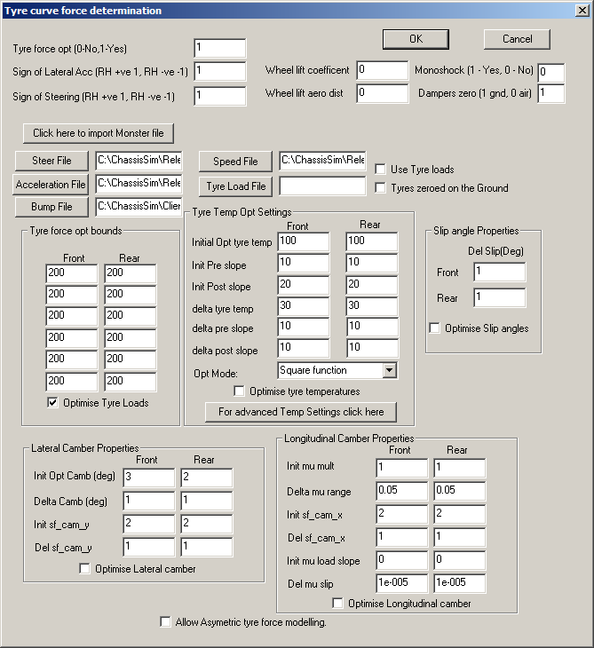

As we can see keep the tyre force bounds to 200 N. This reflects the small load range of a FSAE tyre. It is also recommended to omit the tyre force estimation procedure and head straight to tyre force modelling. However it is recommended to do basic correlation work as outlined in this series of video tutorials,

http://www.youtube.com/watch?v=KZsGn2Fpi1g&list=UU4W7Lqv3XrQps-RlcR4fEOA&index=3&feature=plcp

Conclusion

As can be seen while FSAE car represent a unique racecar with a few modification ChassisSim can be easily adapted to model these race cars. In summary the steps that need to be followed are,
- Modifying Circuit->Modelling options as outlined.
- Using a moving average filter for circuit filtering.
- Using the tyre quick start to dial in slip angles if needed.
- Adjusting the load delta’s in the tyre force modelling toolbox

If these steps are taken then you should have your models dialled in no time.

